**Setting Arduino UNO R4 Minima into bootloader mode**

In order to set the Arduino UNO R4 Minima in bootloader mode the following steps have to be completed:

1. Connect BOOT pin to GND  
   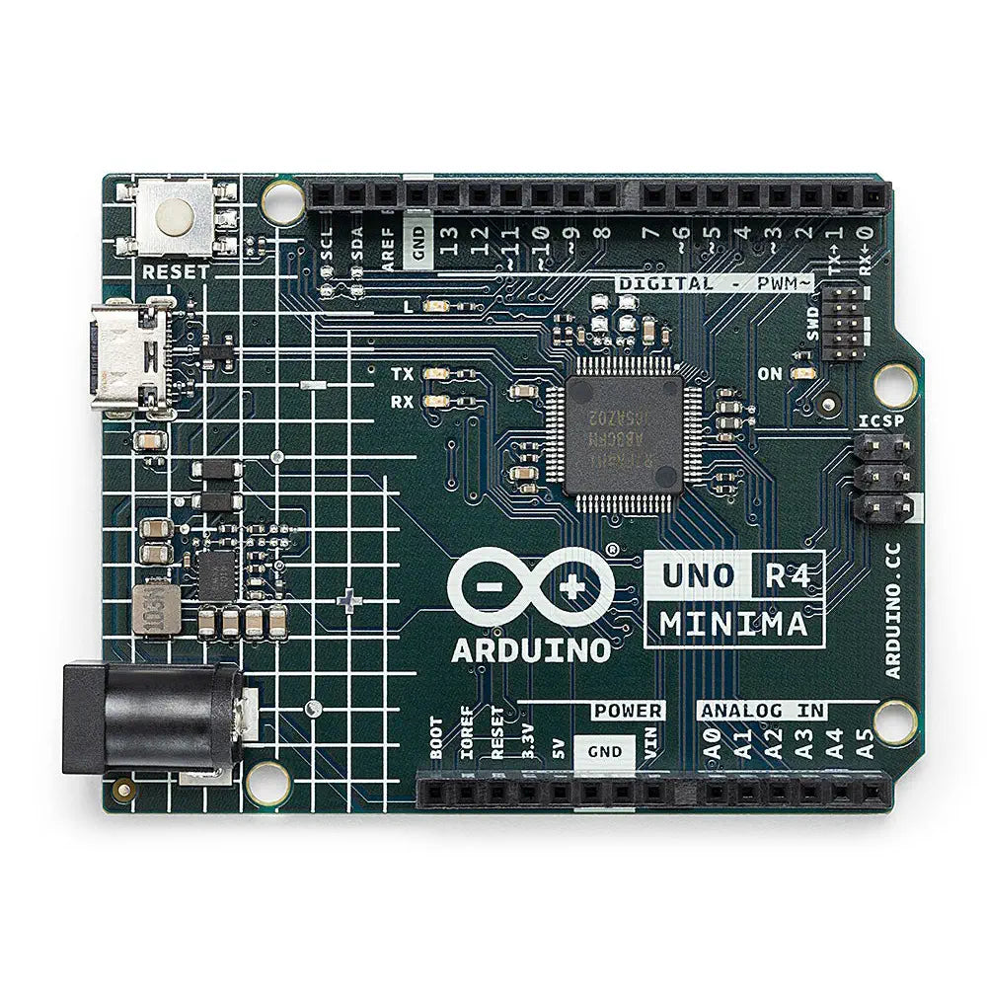

RESET

USB-C

1. Connect the USB-C cable to the board and the P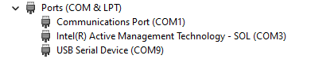C – it will appear as some COM port
2. Press and release the Reset button – it will appear as different COM port in the Device Manager

